Supplementary Information

‘Measuring the transport of new make spirits through American white oak’
by
Taylor Scott, Jarrad Gollihue, Micheal Sama, Michael Shaffer, Brad Berron

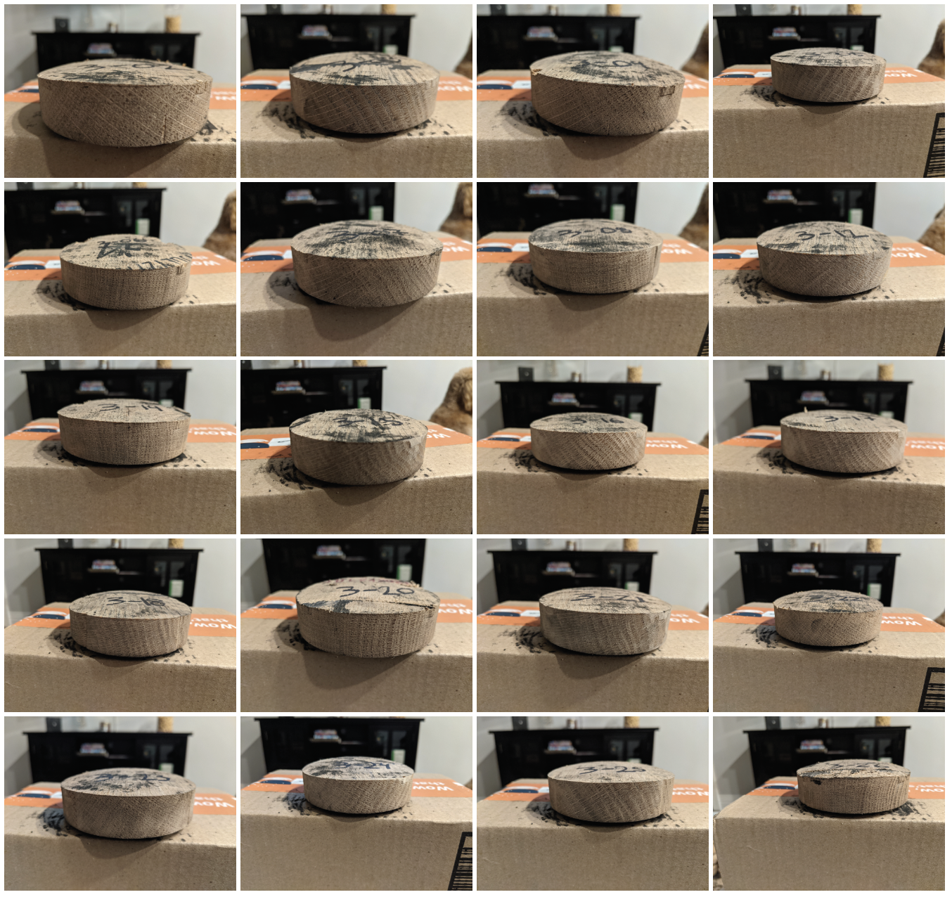
Figure S1. Photos of grain angle for each of the 7.6 cm stave disks.

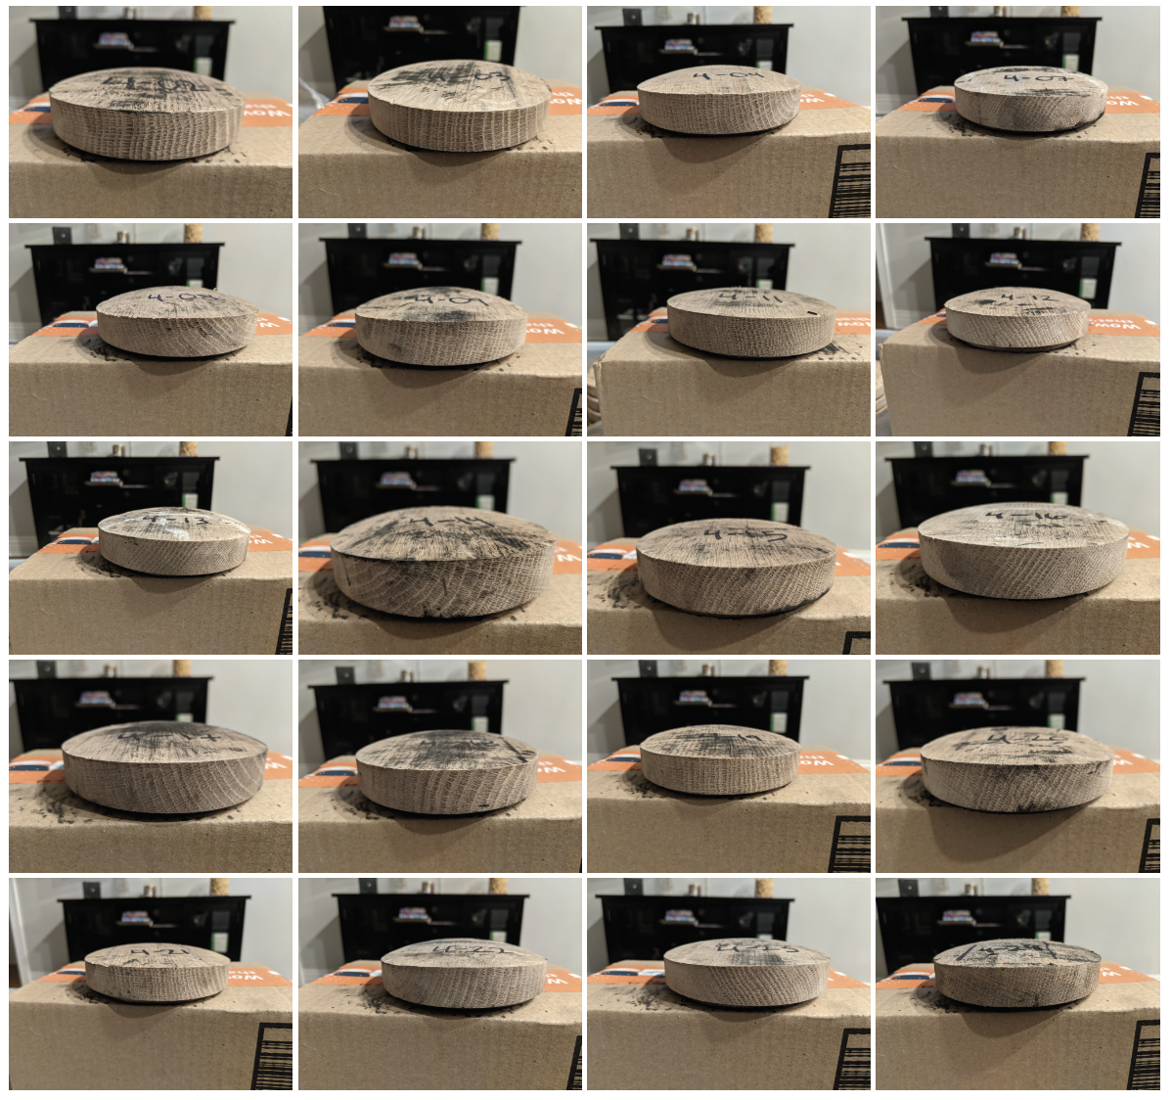
Figure S2. Photos of grain angle for each of the 10.2 cm stave disks.
Month | P Value | Significance
8 – Aug ‘22 | 0.0295 | *
17 – May ‘23 | 0.0017 | **

Table S2. Results of the mixed-effects analysis and Turkey’s multiple comparisons test showing which groups had a statistically significant difference in the monthly flux for liquid vs. vapor contact with the stave disk.
Month | Entry % ABV | P Value | Significance
8 – Aug ‘22 | 50 vs. 70 | 0.0046 | **
8 – Aug ‘22 | 62.5 vs. 70 | 0.0143 | *
9 – Sept ‘22 | 50 vs. 70 | 0.0004 | ***
9 – Sept ‘22 | 62.5 vs. 70 | 0.0190 | *
10 – Oct ‘22 | 50 vs. 70 | 0.0048 | **
10 – Oct ‘22 | 62.5 vs. 70 | 0.0003 | ***
15 – Mar ‘23 | 50 vs. 70 | 0.0014 | **
17 – May ‘23 | 50 vs. 70 | 0.0016 | **
17 – May ‘23 | 62.5 vs. 70 | 0.0096 | **
18 – Jun ‘23 | 50 vs. 70 | <0.0001 | ****
18 – Jun ‘23 | 62.5 vs. 70 | 0.0346 | *
19 – Jul ‘23 | 50 vs. 70 | <0.0001 | ****
19 – Jul ‘23 | 62.5 vs. 70 | 0.0402 | *
20 – Aug ‘23 | 50 vs. 70 | 0.0207 | *
21 – Sept ‘23 | 50 vs. 70 | 0.0003 | ***
21 – Sept ‘23 | 62.5 vs. 70 | 0.0082 | **
23 – Nov ‘23 | 50 vs. 70 | 0.0446 | *
24 – Dec ‘23 | 50 vs. 70 | 0.0489 | *
25 – Jan ‘23 | 50 vs. 70 | 0.0001 | ***

Table S1. Results of the mixed-effects analysis and Turkey’s multiple comparisons test showing which groups had a statistically significant difference in the monthly flux for entry alcohol content.

Month | Stave Disk 1 Mass (g) | Stave Disk 2 Mass (g) | Stave Disk 3 Mass (g)
0 – Oct ‘24 | 123.5 | 133.2 | 107.5
1 – Nov ‘24 | 124.4 | 134.0 | 108.2
2 – Dec ‘24 | 124.2 | 133.8 | 108.1
3 – Jan ‘25 | 124.1 | 133.7 | 108.0

Table S3. Mass of stave disks placed in the warehouse in Frankfort, KY, over three months (October 2024-January 2025).

