Supplementary information

Comparison of laboratory scale bourbon whiskey mashing and fermentation to pilot scale

Table S1. Particle size distribution for grains used at the lab-scale.

Grain Type | Percent retained on sieve |  |  |  |  |  |  |  | Total
Grain Type | 2380 μm | 1180 μm | 425 μm | 300 μm | 250 μm | 180 μm | 75 μm | Pan | Total
Corn | 0% | 11% | 67% | 5% | 3% | 10% | 3% | 0% | 100%
Rye | 0% | 16% | 55% | 8% | 3% | 13% | 4% | 1% | 100%
Barley Malt | 1% | 21% | 47% | 8% | 2% | 7% | 9% | 4% | 100%

Table S2. Rapid visco analyser (RVA) individual grains temperature profile

Time | Type | Value
00:00 | Temp. | 50°C
00:00 | Speed | 960 RPM
00:10 | Speed | 160 RPM
01:00 | Temp. | 50°C
04:42 | Temp. | 95°C or 122°C
7.12 | Temp. | 95°C or 122°C
11:00 | Temp. | 50°C
End of test time: 13:00 (mm:ss)
Initial idle temperature: 50 ± 2°C
Time between readings: 4 s
Viscosity units: cP (≙ mPas)

Table S3. Rapid visco analyser (RVA) Mash Temperature Profiles

Single Bourbon mash conversion process (Simultaneous Saccharification and Fermentation [SSF]) |  |  | Multi-step Bourbon mash conversion process (conventional mash)
Time | Type | Speed | Time | Type | Value
00:00 | Temp. | 25°C | Add 6.83g Corn
00:00 | Speed | 960 RPM | 00:00 | Temp. | 93°C
00:10 | Speed | 160 RPM | 00:00 | Speed | 960 RPM
10:00 | Temp. | 122°C | 00:10 | Speed | 160 RPM
1:00:00 | End |  | 01:00 | Temp. | 93°C
Add 1.5uL enzyme mix |  |  | 30:00 | Temp. | 93°C
00:00 | Temp. | 30°C | 35:00 | Temp. | 77°C
00:00 | Speed | 960 RPM | 35:00 | End
00:10 | Speed | 160 RPM | Add 1.37g Rye
30:00 | End |  | 00:00 | Temp. | 77°C
 |  |  | 00:00 | Speed | 960 RPM
 |  |  | 00:10 | Speed | 160 RPM
 |  |  | 01:00 | Temp. | 77°C
 |  |  | 10:00 | Temp. | 77°C
 |  |  | 15:00 | Temp. | 63°C
 |  |  | 15:00 | End
 |  |  | Add 0.911g Malt
 |  |  | 00:00 | Temp. | 63°C
 |  |  | 00:00 | Speed | 960 RPM
 |  |  | 00:10 | Speed | 160 RPM
 |  |  | 15:00 | Temp. | 63°C
 |  |  | 25:00 | Temp. | 30°C
 |  |  | 25:00 | End
 |  |  | Add 1.5uL enzyme mix
 |  |  | 00:00 | Temp. | 30°C
 |  |  | 00:00 | Speed | 960 RPM
 |  |  | 00:10 | Speed | 160 RPM
 |  |  | 30:00 | End

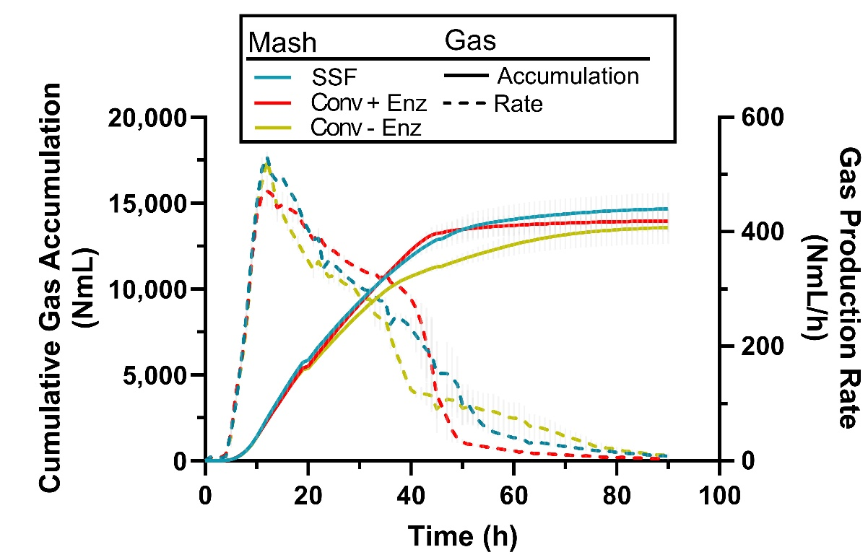

Figure S4. Gas production (solid lines) and gas production flow (dashed lines) for lab-scale conventional (Conv) with and without added enzymes and Simultaneous Saccharification and Fermentation (SSF) mashing methods.

